ZD,
REPORT OF JOINT INVESTIGATION VISIT FOR 18’’ TEBIDABA/BRASS PIPELINE AT BENIKRUKRU SOUTHERN IJAW LOCAL GOVERNMENT BAYELSA STATE.
The Agency was informed of an oil spill incident at the above mentioned location and joint inspection visit involving the Regulators and NOAC was conducted on 01/04/2015.The inspection team at the site included the following:
i. Bawah Tabat. J NOSDRA
ii. Briseimo Z. Frank BYSMENV
iii. Benson Ogbe NOAC CRV
iv. Ahiakwo N. Felix HSE NAOC
SITE DETAILS
i. FIELD INCIDENT NUMBER 2015/SAR/084
ii. FACILITY 18” Tebidaba/Brass pipeline
iii. DATE OF INCIDENT 01 April, 2015
iv. DATE REPORTED 01 April, 2015
v. DATE OF JIV 01 April, 2015
vi. SPILL COORDINATES. N 04° 32’ 13.1”, E 005° 58’ 47.8”
vii. CAUSE OF SPILL Sabotage
viii. AREA OF IMPACT Nil
x. ESTIMATED VOLUME OF SPILL Nil
OBSERVATIONS
i. Unknown persons installed 3” valve on the facility for crude oil theft activities.
ii. 3’’ valve was observed to be installed at 12 o’clock position at the time of JIV.
iii. It was within the right of way (ROW)
iv. Repair of pipeline was initiated and completed.

PICTURES OF SITE
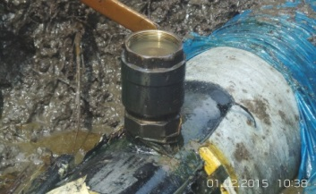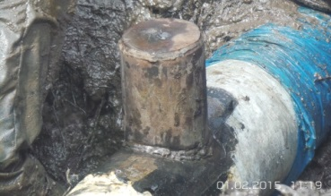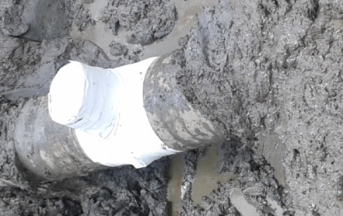
Spill point pipeline under repair Repaired pipeline

RECOMMENDATION
There should be proper surveillance on the pipelines to avoid unnecessary repairs.

CONCLUSION
In conclusion the JIV/Repairs and delimitation survey completed on 01 April 2015,
clean-up not required.
JIV was successfully carried out and hereby submitted for your input and further
directives.

Bawah Tabat. J (ESII)

